California Waves 18U

Jaleesa A. Garcia #27 Class of 2022

Positions: SS, 3B

Running: Home to First: Home to Home: Throws: R Bats: R

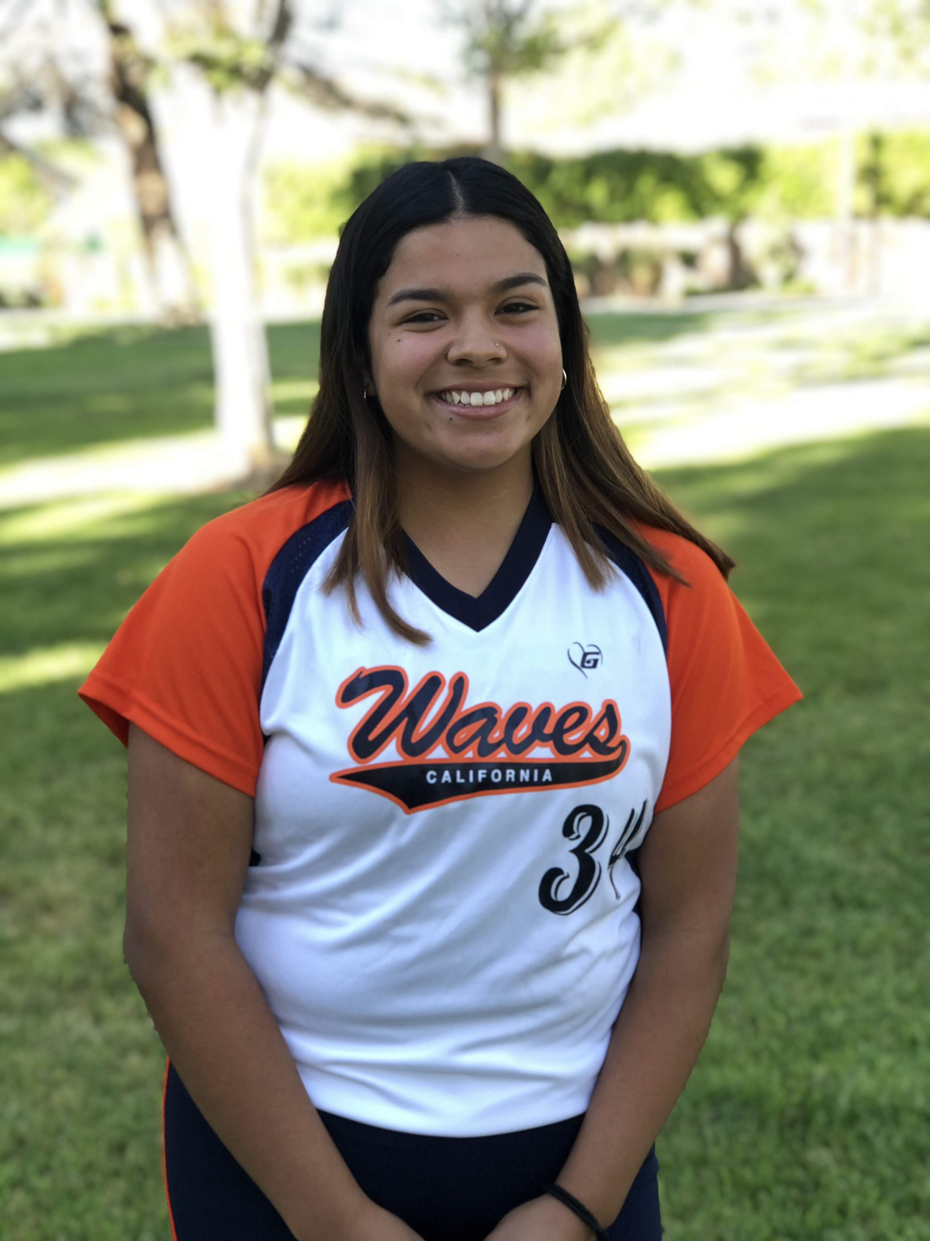

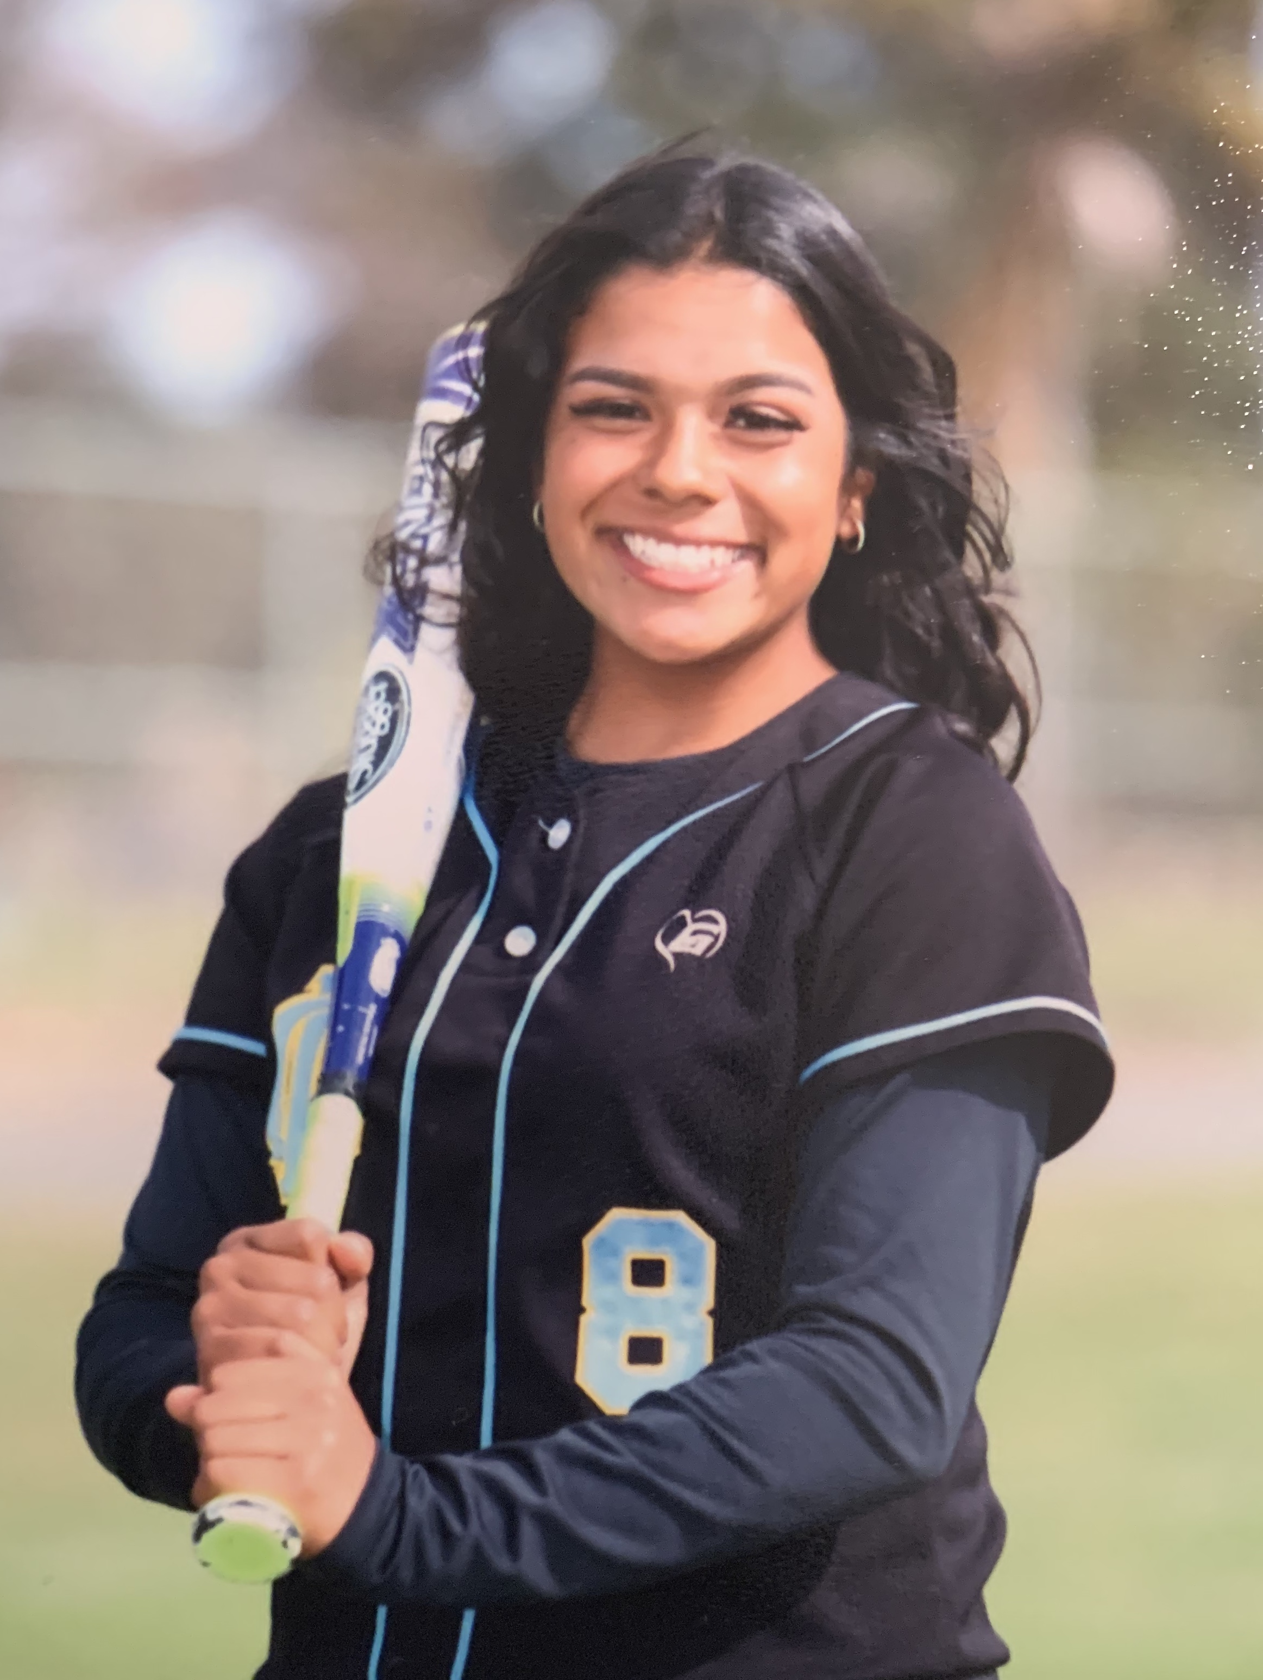

Academic Profile:

GPA: 4.0 SAT: NYT ACT: NYT

NCAA Clearinghouse:

High School:

Channel Islands High School

1400 Raiders Way, Oxnard, CA 93033

Personal Profile:

D.O.B. 10/20/2004 Ht: 5’3” Wt: 168 Lbs.

Parents: Juan and Sonia

5453 Barrymore Dr., Oxnard, CA 93033

Email: [jaleesagee1020@gmail.com](mailto:jaleesagee1020@gmail.com)

Phone: 805-415-0774

Athletic Achievements:

2015: Seaside 10U All Start

2017: So. Cal Lady Bombers USSSA Nationals 4th Place

2019: 2nd Team All-League

2019: MVP

Academic Achievements:

2014: Writing Award

2018-2019: Valedictorian Honor Roll

2019-2020: Valedictorian Honor Roll

Coaching Information:

Travel Ball:

California Waves, 18U

Manager: Robert Ives (805) 657-5142

[xtree23@aol.com](mailto:xtree23@aol.com)

High School:

CIHS Head Coach: Steve Lopez

805-827-3818

[vc.rangers@yahoo.com](mailto:vc.rangers@yahoo.com)

Skills Video:

Other Interests:

Writing

Soccer

Volleyball

Community Service:

2020: Church Event-Lenten Soup Day

2020: End Hunger Walk